**DAILY ONLINE ACTIVITIES SUMMARY**

|  |  |  |  |  |  |  |  |
| --- | --- | --- | --- | --- | --- | --- | --- |
| **Date:** | **11/06/2020** | | | | **Name:** | **Syed Rabeya Aamir** | |
| **Sem & Sec** | **8th B** | | | | **USN:** | **4AL16CS112** | |
| Online Test Summary | | | | | | | |
| **Subject** | | **SMS** | | | | | |
| **Max. Marks** | | **60** | | **Score** | | **60** | |
| Certification Course Summary | | | | | | | |
| **Course** | **Aws cloud practitioner essential** | | | | | | |
| **Certificate Provider** | | | **Aws** | **Duration** | | | **6 hrs** |
| Coding Challenges | | | | | | | |
| **Problem Statement:**  **1)Python Program to find the L.C.M. of two input number.** | | | | | | | |
| **Status: Solved** | | | | | | | |
| **Uploaded the report in Github** | | | | **YES** | | | |
| **If yes Repository name** | | | | **rabeya** | | | |
| **Uploaded the report in slack** | | | | **YES** | | | |

**Online Test:**

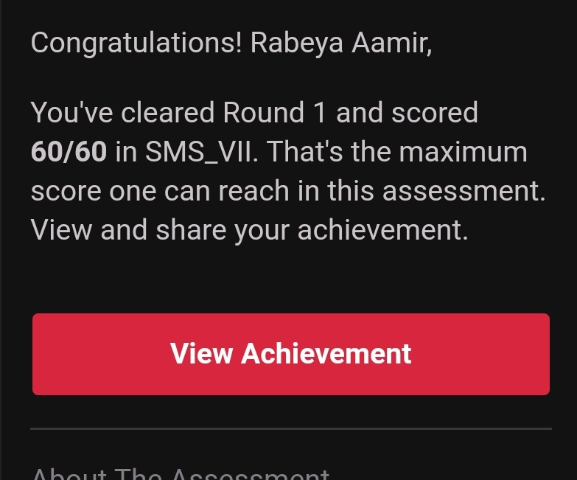

**Certification Course Details:**

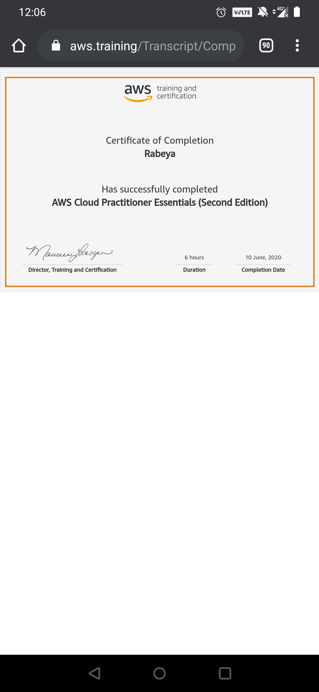

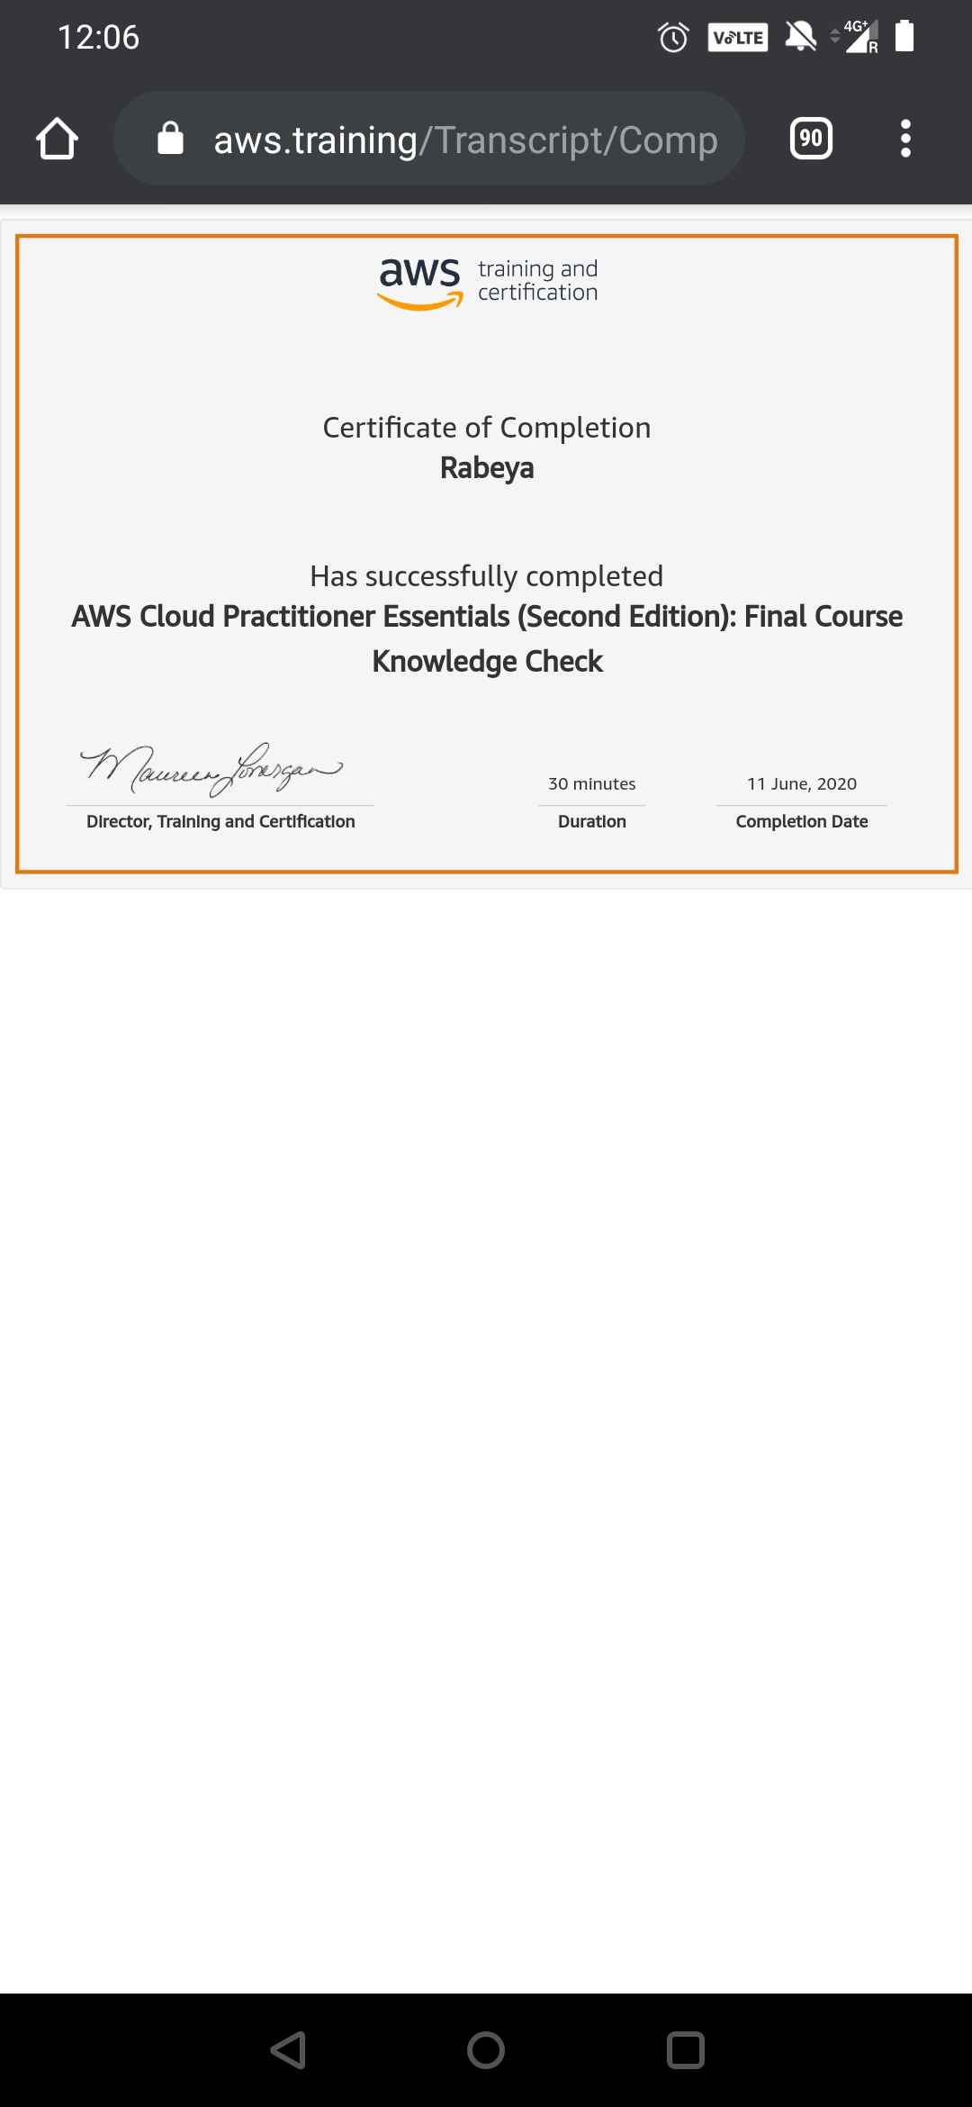

# CODE:

Program no:1

# Python Program to find the L.C.M. of two input number

def compute_lcm(x, y):

# choose the greater number

if x > y:

greater = x

else:

greater = y

while(True):

if((greater % x == 0) and (greater % y == 0)):

lcm = greater

break

greater += 1

return lcm

num1 = 54

num2 = 24

print("The L.C.M. is", compute_lcm(num1, num2))